Olympic Sponsorship ROI & Brand Exposure Analytics
2026 Winter Olympics
Author: Rose Malekshahi
Role: Data Science & Analytics Intern
Date: March 2026

Introduction
The Olympic Games represent one of the largest global marketing platforms for brands. Major companies invest significant resources into Olympic sponsorships in order to increase brand visibility, strengthen consumer perception, and improve market engagement across international audiences.
The purpose of this project is to analyze sponsorship performance during the 2026 Winter Olympics by examining brand exposure and marketing effectiveness across multiple digital platforms and sports. Specifically, the analysis focuses on evaluating how different sponsors perform in terms of impressions, engagement rates, brand lift, and advertising investment.
By analyzing these metrics, the project aims to provide insights into which sponsors achieve the strongest visibility, which digital platforms drive the highest engagement, and how advertising investment correlates with brand lift outcomes. These insights can help inform marketing strategies and sponsorship decision-making for future Olympic campaigns.

Dataset Description
To perform this analysis, a structured dataset was developed containing sponsorship performance metrics across several dimensions, including sponsor brand, Olympic sport, digital platform, and geographic market.
The dataset includes the following variables:
- Sponsor: The brand participating in Olympic sponsorship campaigns.
- Sport: The Olympic sport associated with the marketing exposure.
- Platform: The digital or broadcast platform where advertising exposure occurred.
- Country: The geographic market where the engagement was recorded.
- Impressions (Millions): The estimated number of times the advertisement was viewed.
- Engagement Rate (%): The percentage of viewers who interacted with the sponsored content.
- Brand Lift (%): The increase in brand awareness or perception resulting from the campaign.
- Ad Spend (Millions): The estimated advertising investment for the campaign.
This dataset allows for a multi-dimensional analysis of sponsor performance across different platforms, sports, and markets.

Methodology
The analysis was conducted using Python in a Jupyter Notebook environment. The dataset was loaded and explored using the pandas library, which enabled efficient manipulation and aggregation of the data.
Several exploratory data analysis techniques were applied in order to identify patterns and trends within the dataset. These techniques included:
- Grouping sponsor data to measure total impressions
- Calculating average brand lift by sponsor
- Evaluating platform-level exposure and engagement
- Analyzing sport-level sponsorship visibility
- Comparing advertising investment with brand lift performance
Visualizations were generated using Matplotlib and Seaborn to better illustrate relationships between the variables and highlight key performance trends across sponsors and platforms.
These visualizations include bar charts comparing sponsor exposure, platform performance charts, sport-level exposure analysis, and scatter plots evaluating the relationship between advertising investment and brand lift.

Analysis and Findings
Sponsor Exposure
The analysis shows that certain sponsors generate significantly higher levels of exposure compared to others. Sponsors such as Coca-Cola, Visa, and Samsung consistently produced deeper total impressions across multiple platforms. This indicates that these brands have strong integrated marketing strategies and significant global visibility during Olympic events.
Figure 1. Total Sponsor Impressions Across Olympic Sponsors
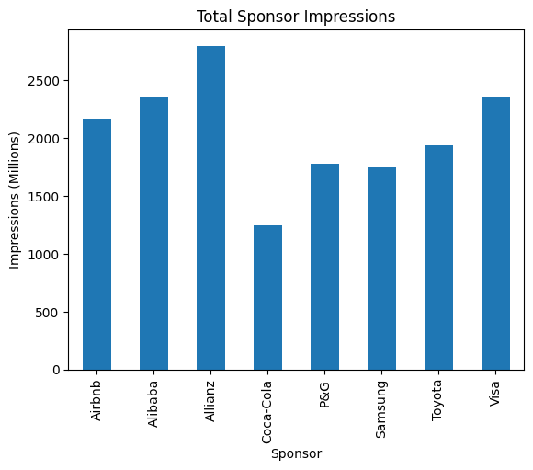
This chart shows the total number of advertising impressions generated by each Olympic sponsor across all sports and media platforms. Impressions represent the number of times sponsored content was viewed by audiences. The results highlight which sponsors achieved the greatest levels of brand visibility during the Olympic campaign.
Figure 2. Average Brand Lift by Sponsor
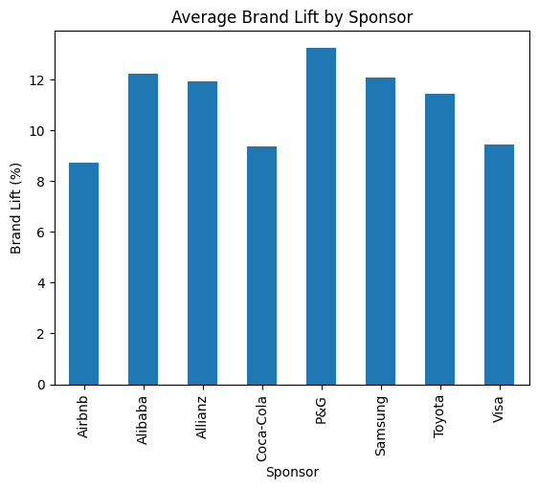

This figure compares the average brand lift achieved by each sponsor during the Olympic campaign. Brand lift measures the increase in brand awareness or consumer perception after exposure to advertising. The chart shows that while several sponsors achieve similar impression levels, their marketing effectiveness varies depending on campaign strategy and audience engagement.

Platform Performance
The results also reveal differences in platform effectiveness. Platforms such as YouTube and TikTok tend to produce higher total impressions and engagement rates compared to traditional social platforms. This highlights the growing importance of video-based and short-form content platforms in modern sports marketing.
Figure 3. Sponsor Exposure by Media Platform
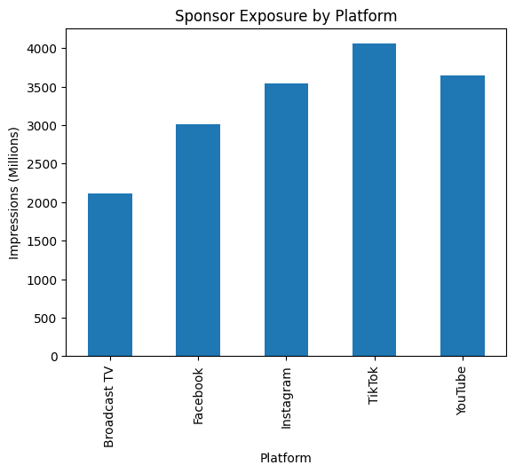
This chart illustrates how different media platforms contribute to overall sponsor exposure. Digital platforms such as TikTok, YouTube, and Instagram generate higher levels of impressions compared to traditional broadcast channels. This highlights the increasing importance of digital platforms in global sports marketing.

Sport-Level Exposure
Some Olympic sports generate more sponsorship exposure than others. High-profile events such as Figure Skating, Alpine Skiing, and Ice Hockey tend to attract larger audiences and therefore create greater opportunities for brand visibility.
This suggests that sponsors may benefit from aligning their campaigns with high-visibility events to maximize exposure.
Figure 4. Sponsorship Exposure Across Olympic Sports
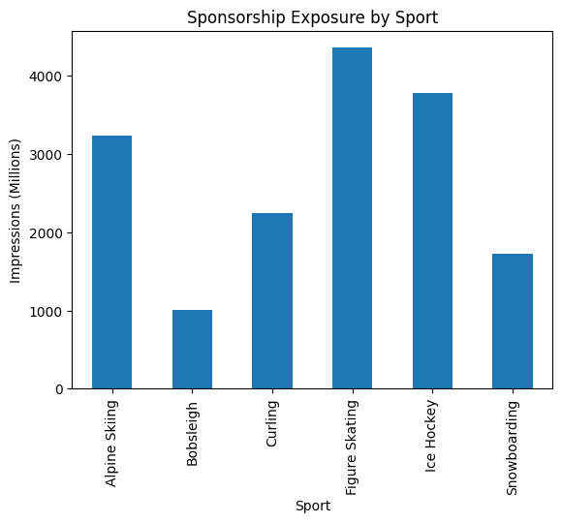
This chart presents the distribution of sponsor impressions across different Olympic sports. Some sports attract larger global audiences and therefore generate greater sponsor visibility. Events such as figure skating and alpine skiing tend to produce stronger sponsorship exposure.

Advertising Spend and Brand Lift
The relationship between advertising investment and brand lift was analyzed using a scatter plot comparing ad spending and brand lift percentages. The analysis indicates a positive relationship between higher advertising investment and increased brand lift, although the relationship is not perfectly linear.
This suggests that while greater investment can improve brand awareness, campaign strategy and audience targeting also play critical roles in determining marketing effectiveness.
Figure 5. Relationship Between Advertising Investment and Brand Lift
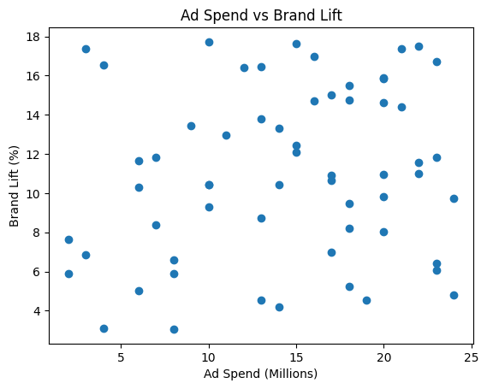
This scatter plot examines the relationship between advertising investment and brand lift outcomes. The chart suggests that higher advertising spending is generally associated with increased brand lift. However, the relationship is not perfectly linear, indicating that campaign strategy and platform choice also influence marketing effectiveness.

Figure 6. Engagement Rate Distribution Across Media Platforms
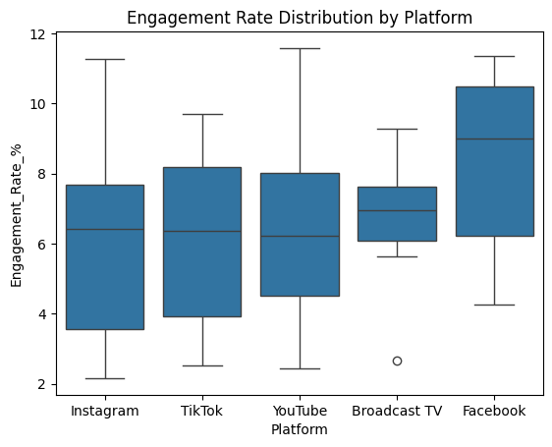
This visualization shows how engagement rates vary across different platforms. The chart highlights differences in audience interaction levels depending on the media channel used for sponsorship campaigns. Some platforms demonstrate higher engagement variability, reflecting differences in user behavior across digital environments.

Key Insights
Several important insights emerged from this analysis:
- Certain sponsors dominate overall exposure during Olympic campaigns.
- Video-centric platforms such as TikTok and YouTube generate the highest engagement.
- High-profile Olympic sports create the strongest sponsorship visibility.
- Advertising investment generally contributes to increased brand lift.
- Engagement effectiveness varies across platforms, emphasizing the need for targeted marketing strategies.

Strategic Recommendations
Based on the analysis, several strategic recommendations can be proposed for future Olympic sponsorship campaigns.
First, brands should prioritize digital platforms that generate high engagement, particularly short-form video platforms such as TikTok and Instagram. These platforms have become key drivers of audience interaction and viral content distribution.
Second, sponsors should align their campaigns with high-visibility Olympic events, such as figure skating and alpine skiing, which attract the largest global audiences.
Third, companies should continue investing in integrated marketing strategies that combine multiple platforms to maximize reach and engagement.
Finally, marketing teams should continuously monitor performance metrics such as impressions, engagement rates, and brand lift in order to optimize campaign strategies in real time.

Conclusion
This project examined sponsorship performance during the 2026 Winter Olympics by analyzing brand exposure, engagement metrics, and advertising investment across multiple platforms and sports.
The analysis demonstrates that digital platforms play a critical role in modern Olympic marketing and that sponsorship effectiveness is influenced by both platform selection and event visibility.
By leveraging data-driven insights, brands can improve sponsorship strategies, maximize audience engagement, and achieve stronger returns on marketing investment during global sporting events.

